**DevOps 2019 training. Dennis Tikhomirov. 06/24/2019**

**Homework.Task2.**

**1. Create a VM with Windows 2016 Server.**

VBoxManage commands for configure and start VM:

**VBoxManage createvm --name "Windows2016Server" —register**

**VBoxManage modifyvm " Windows2016Server " --memory 1024** *//set RAM=1Gb*

**VBoxManage modifyvm " Windows2016Server " --cpus 1** *// number of CPUs=1*

**vboxmanage modifyvm "Windows2016Server" --vram 256**

**VBoxManage storagectl " Windows2016Server " --name SATA --add sata.**  *// add SATA controller with name “SATA”*

**VBoxmanage storageattach "Windows2016Server" --storagectl SATA --type dvddrive –port 2 —medium /Users/dennis/epam/devops/Windows_Server_2016_Datacenter_EVAL_en-us_14393_refresh.ISO** *//attach DVD with Windows Server 2016 installation files*

**VBoxmanage storageattach " Windows2016Server " --storagectl SATA --type dvddrive --port 3 --medium /Users/dennis/epam/devops/VBoxGuestAdditions.iso** *//add Guest Addition*

**VBoxmanage createmedium disk --filename "/Users/dennis/VirtualBox VMs/ Windows2016Server /HDD15GB.vhd" -size 15000 --format VHD** *//create HDD image*

**vboxmanage storageattach " Windows2016Server " --storagectl SATA --port 0 --type hdd --medium "/Users/dennis/VirtualBox VMs/Windows2016Server/HDD15GB.vhd”** *//attach HDD*

**VBoxmanage createmedium disk --filename "/Users/dennis/VirtualBox VMs/ Windows2016Server /HDD1GB.vhd" -size 1024 --format VHD** *//create HDD image*

**vboxmanage storageattach " Windows2016Server " --storagectl SATA --port 0 --type hdd --medium "/Users/dennis/VirtualBox VMs/Windows2016Server/HDD1GB.vhd”** *//attach HDD*

**vboxmanage modifyvm " Windows2016Server " --nic1 hostonly** *//setup Host-only mode for Adapter1*

**vboxmanage startvm " Windows2016Server”**  *//launch VM*

Screenshot#1. Details tab for Win-2016 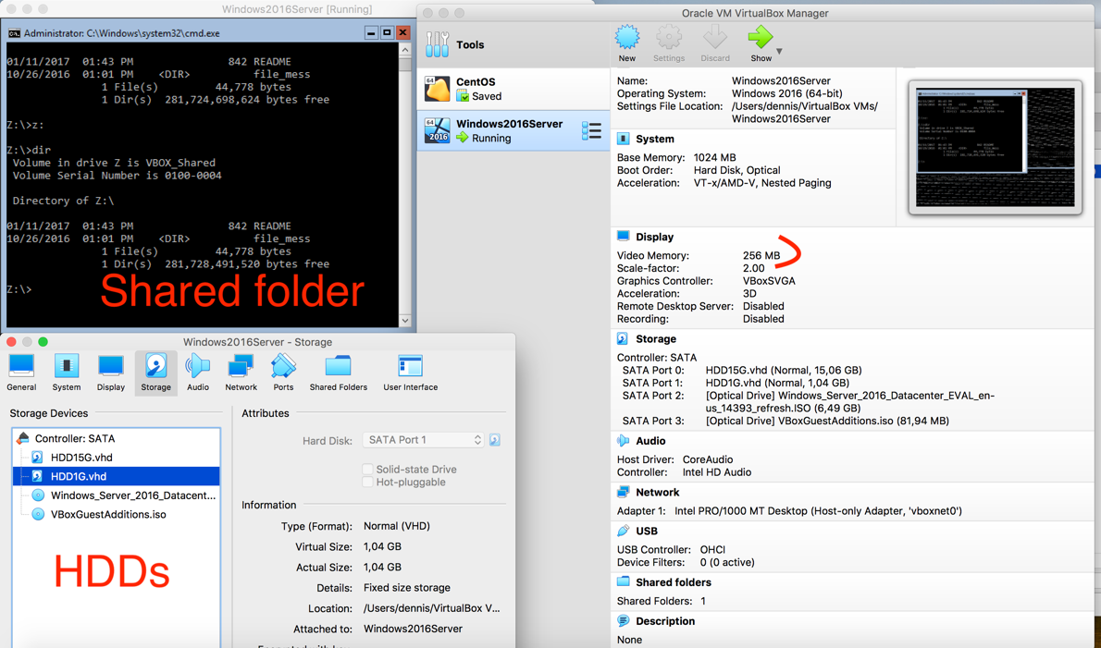

*Notice!*

I couldn’t allocate VRAM more than 256Mb on MacBook Pro, HighSierra.

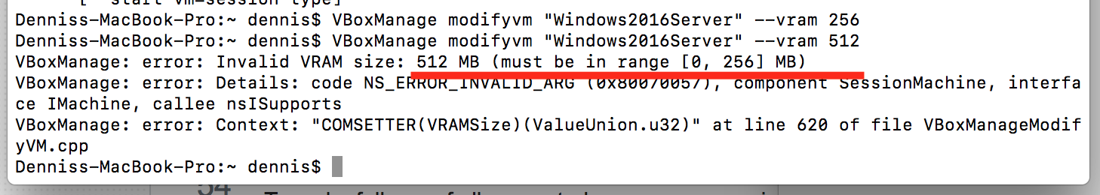

There isn’t a limitation for VRAM in VM documentation <https://docs.oracle.com/cd/E97728_01/E97727/html/settings-display.html> but looks like 256Mb is the upper limit <https://askubuntu.com/questions/587083/virtualbox-how-to-increase-video-memory>

**2. Create three shared folders and map them into guest.**

Screenshot#2. Shared folders.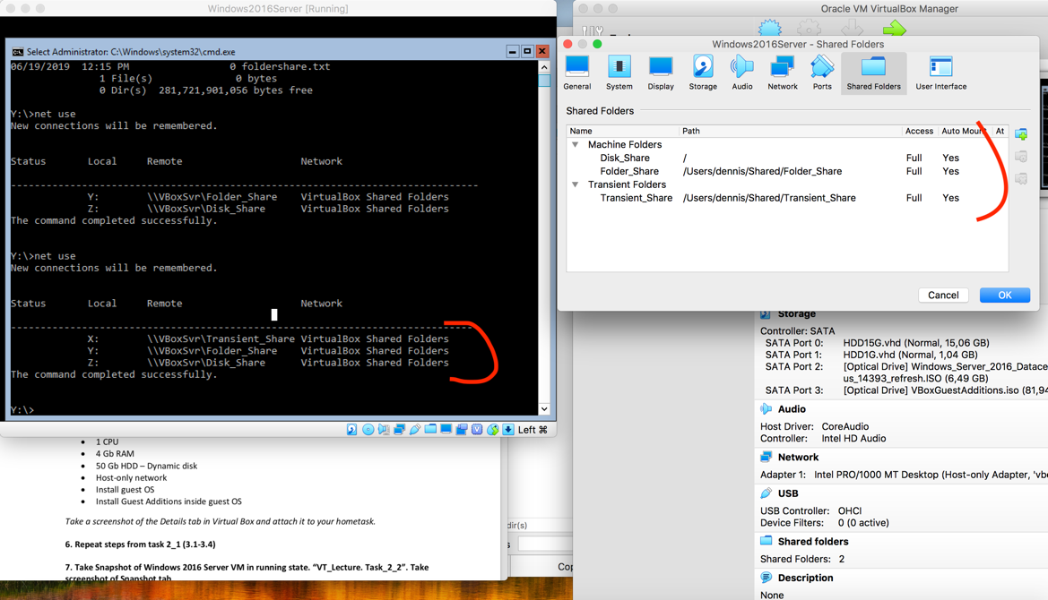

**3. Guest Networking.**

Screenshot#3. IP settings of Windows2016Server VM

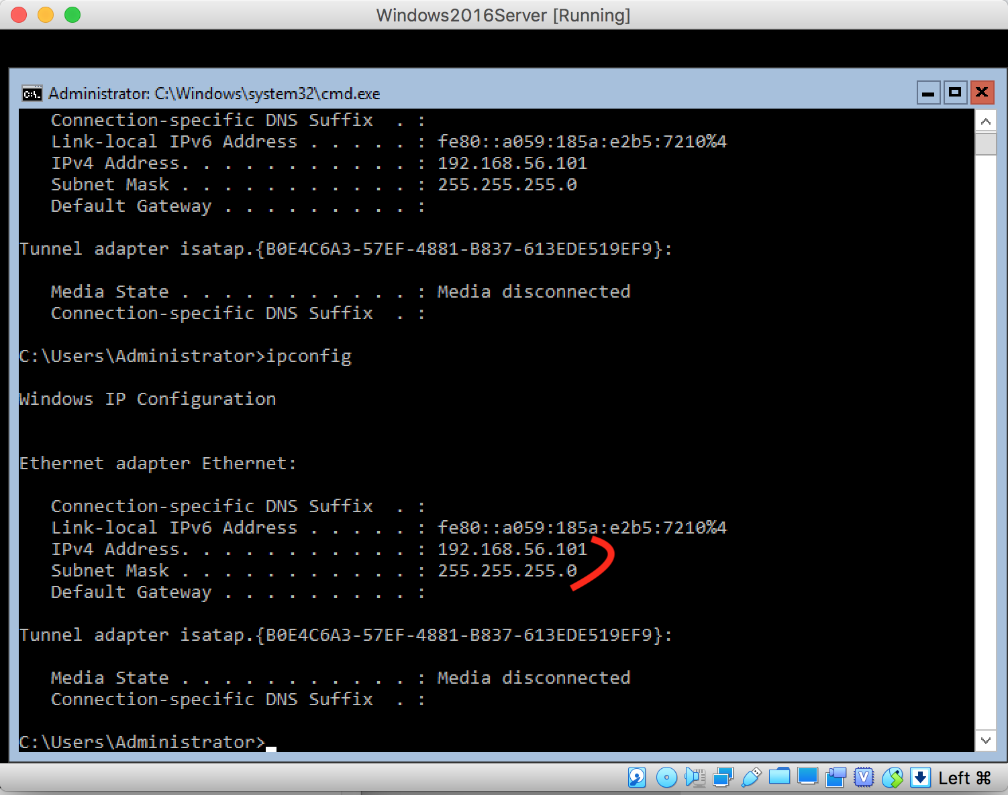

Screenshot #4. Ping statistics – ping from Win-2016 to host.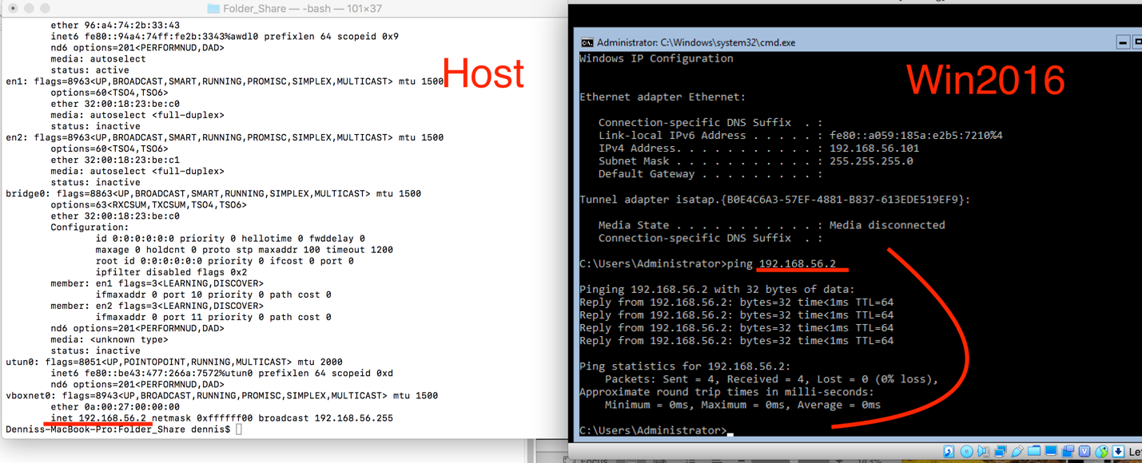

Screenshot #5. Ping statistics – ping from host to Win-2016 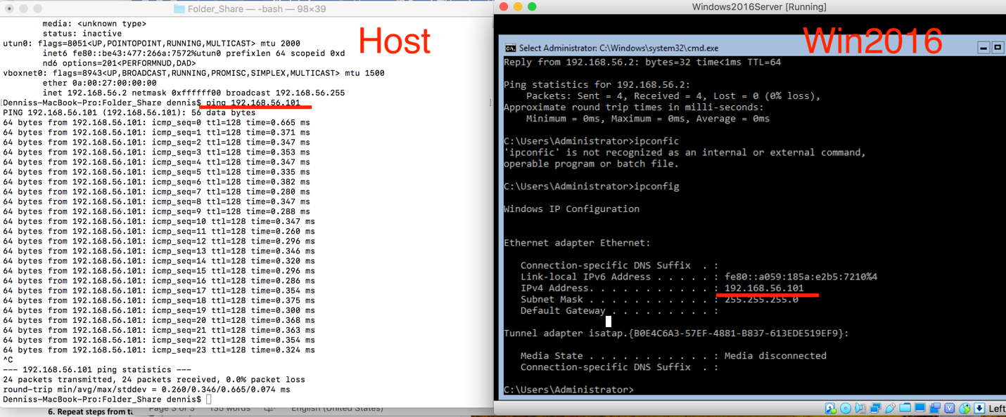

**4. Take a Snapshot of this VM in running state. Name it “VT_Lecture. Task_2_1”. Take screenshot of Snapshot tab**

Command:vboxmanage snapshot "Windows2016Server" take "“VT_Lecture. Task_2_1"

Screenshot #6.Snapshot tab for Win-2016

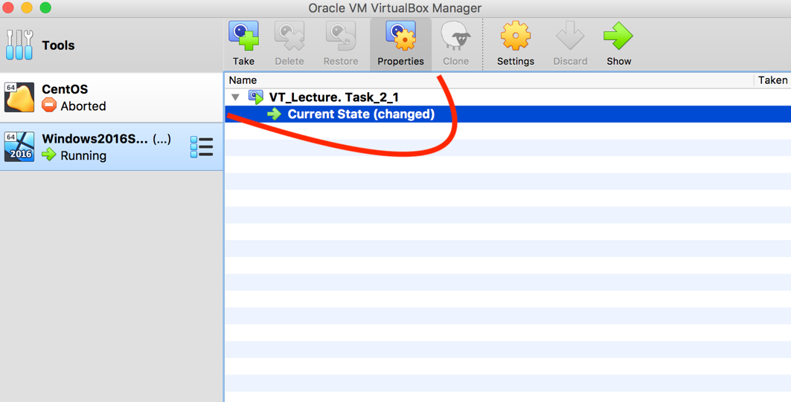

**5. Mount a USB flash drive with some files into the VM and copy these files inside**

Screenshot#7. USB flash inside Win-2016 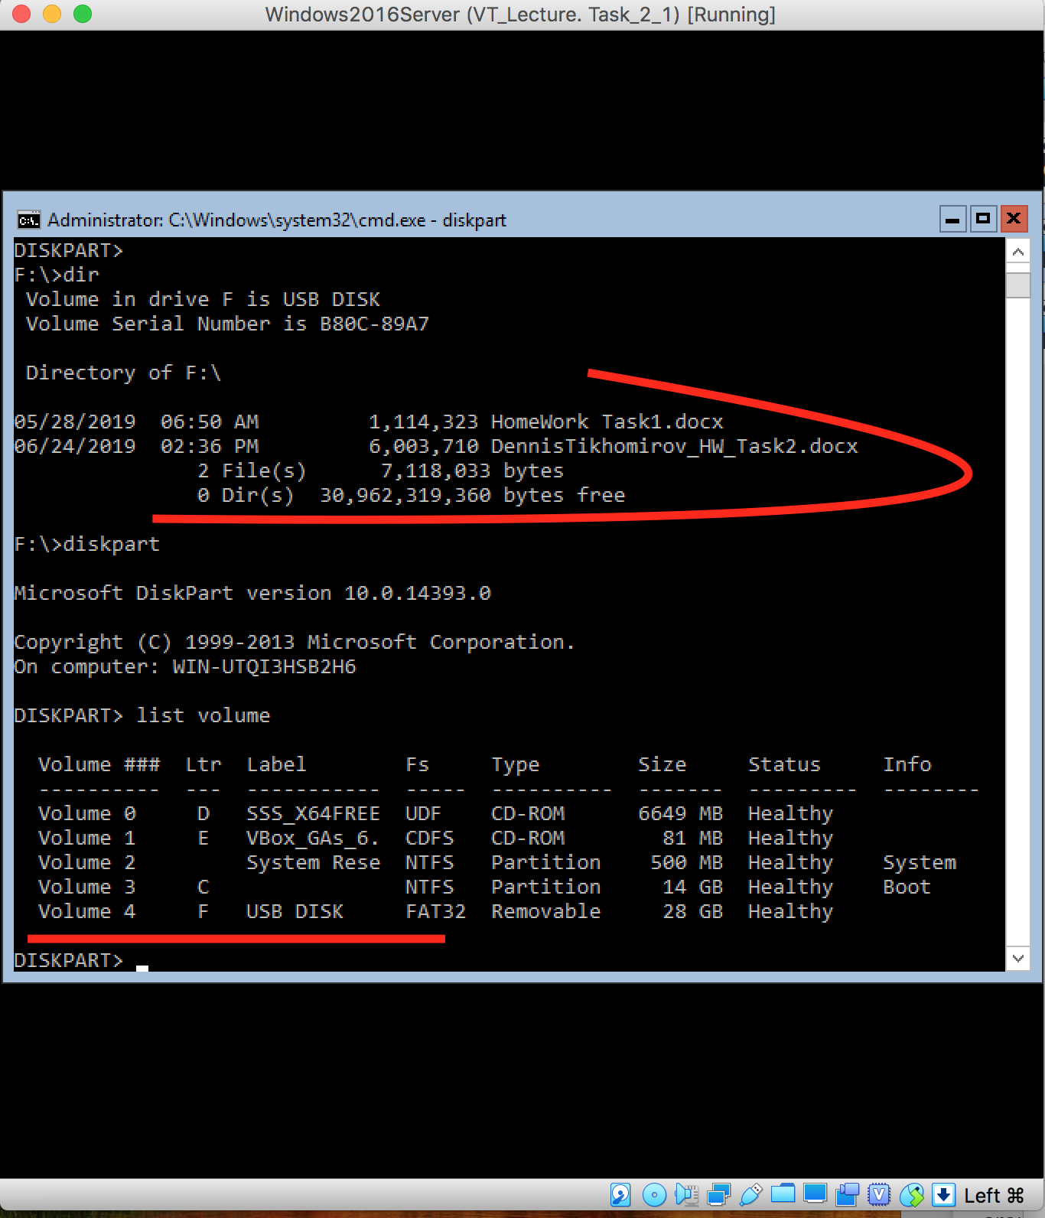

**6. 2nd VM : Windows 2019 Server**

**6.1 Create a VM with Windows 2019 Server.**

VBoxManage commands for configure and start VM:

**VBoxManage createvm --name "Win2019" —register**

**VBoxManage modifyvm "Windows2019" --memory 4096**  //set RAM=4Gb

**VBoxManage modifyvm "Windows2019" --cpus 1** // number of CPUs=1

**VBoxManage storagectl "Windows2019" --name CTL1 --add sata** // add SATA controller with name “CTL1”

**VBoxmanage storageattach "Windows2019" --storagectl CTL1 --type dvddrive --port 1 —medium /Users/dennis/epam/devops/17763.379.190312-0539.rs5_release_svc_refresh_SERVER_EVAL_x64FRE_en-us.iso** //attach DVD with Windows Server 2019 installation files

**VBoxmanage storageattach "Windows2019" --storagectl CTL1 --type dvddrive --port 2 --medium /Users/dennis/epam/devops/VBoxGuestAdditions.iso** //add Guest Addition

**VBoxmanage createmedium disk --filename "/Users/dennis/VirtualBox VMs/Windows2019/HDD50GB.vmdk" -size 50000 --format VHD** //create HDD image

**vboxmanage storageattach "Windows2019" --storagectl CTL1 --port 0 --type hdd --medium "/Users/dennis/VirtualBox VMs/Windows2019/HDD50GB.vmdk”**  //attach HDD

**vboxmanage modifyvm "Windows2019" --nic1 hostonly** //setup Host-only mode for Adapter1

**vboxmanage startvm "Windows2019"**  //launch VM

Screenshot #8. Details tab for Win-2019 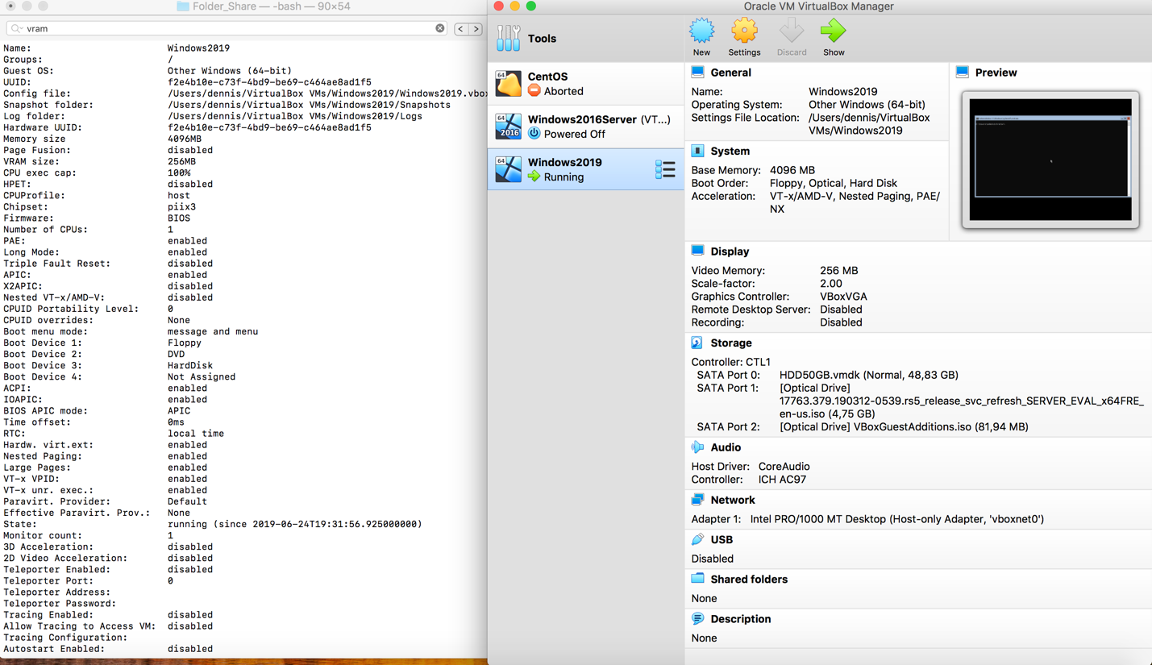

**6.2** Find out IP settings of **Windows 2019 Server** VM

Screenshot #9. IP settings of Win-2019 .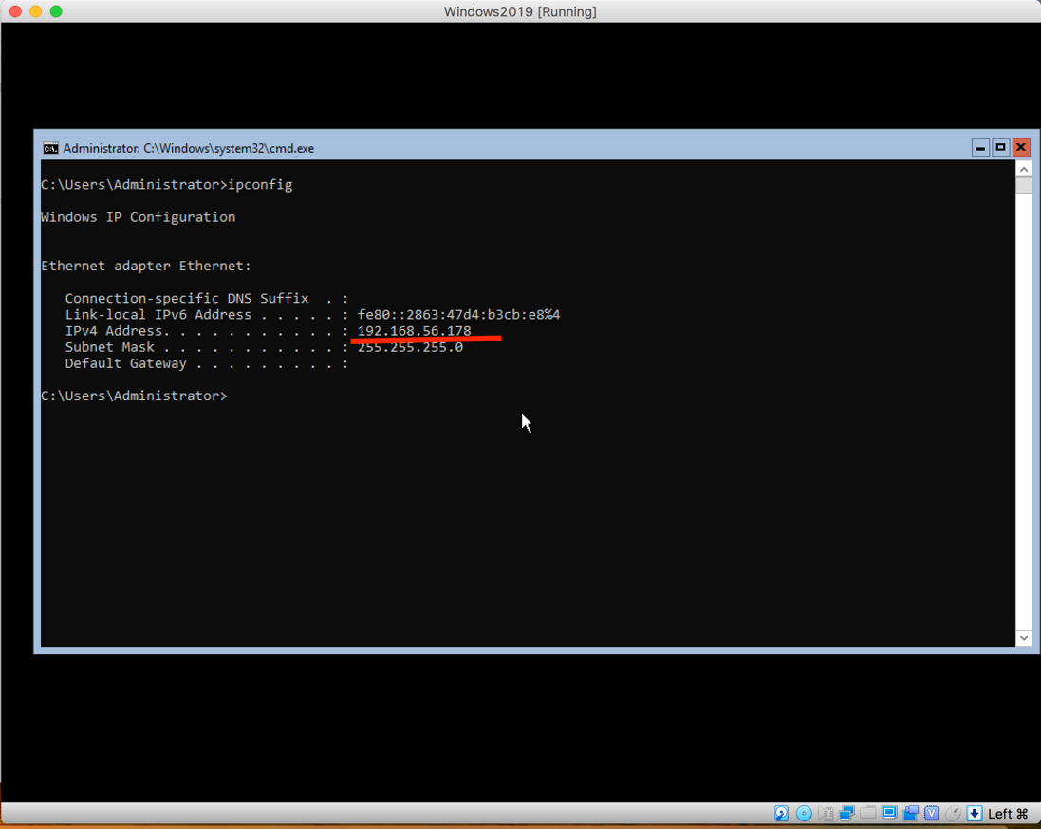

**6.3** Ping statistic from Windows2019Server to host

Screenshot #10. Ping statistics – ping from Win-2019 to host

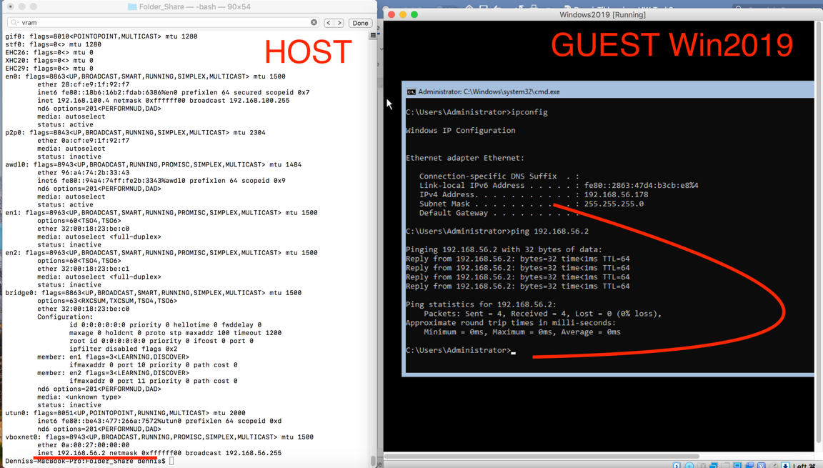

**6.4** Ping statistic from host to Windows2019Server

Screenshot #11. Ping statistics – ping from host to Win-2019 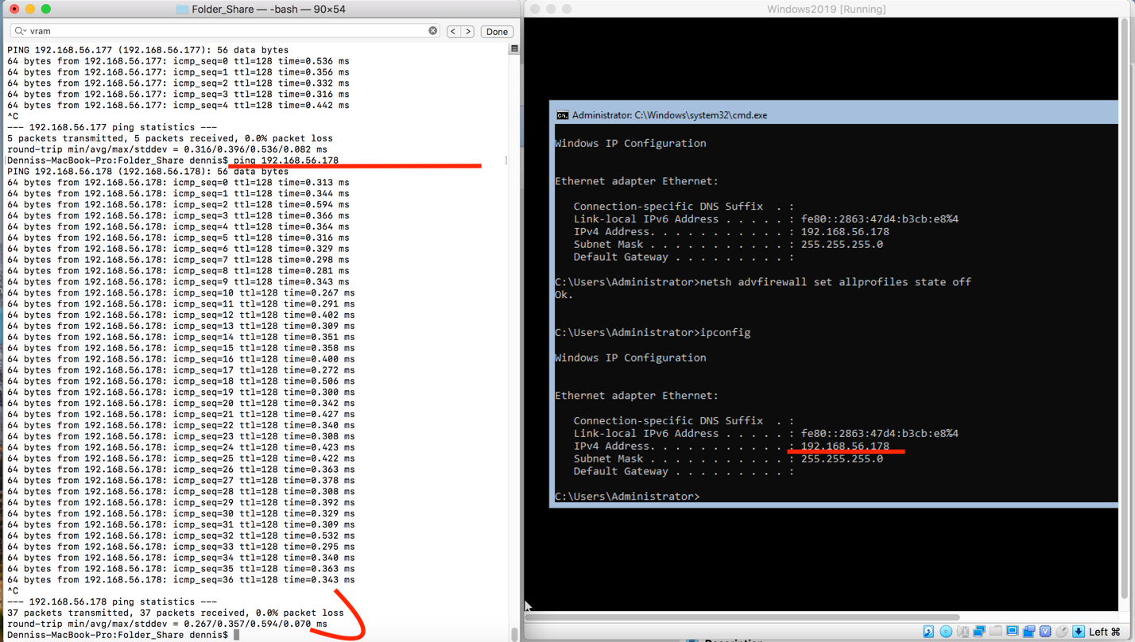

**7. Take Snapshot of Windows 2016 Server VM in running state. “VT_Lecture. Task_2_2”. Take screenshot of Snapshot tab**

vboxmanage snapshot "Windows2019" take "“VT_Lecture. Task_2_2"

Screenshot #14. Snapshot tab for Win-2019 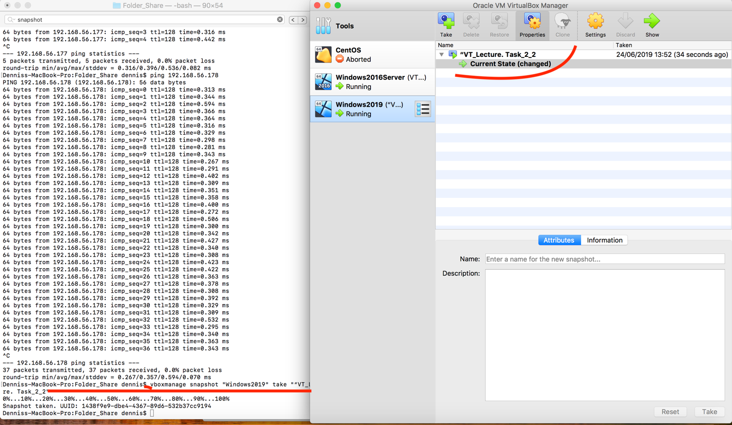

**8. Ping Windows 2016 VM from Windows 2019 and vice versa**

Screenshot #11. Ping from Win-2019 to Win-2016 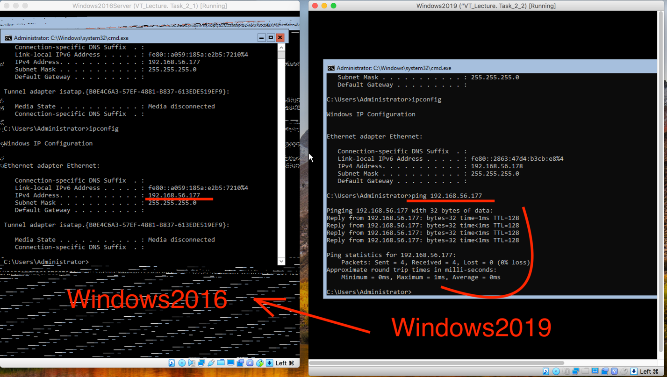

Screenshot #12. Ping from Win-2016 to Win-2019

